Jacksonville Ranch Club 1 New Construction Application (NCA)
Use this Application for New Construction or a 2nd Living Quarters once a home has been built.
2nd Living Quarters must be Minimum of 1500 sq. ft. To Maximum of 50% of main home Living area.
Use the New Construction Checklist (ITEM # 1 NCA) included to ensure that all required documents and information have been submitted with the application to help speed the process. Examples of a complete and properly filled out application can be found on the website along with this application.
Fill out all of the below forms with an (X) and return to the Management Company along with Full Size Plans and the other required Documentation. Place the New Construction Application Checklist for Jacksonville Ranch Club 1 (ITEM # 1 NCA) and the Management Company New Construction Checklist for Jacksonville Ranch Club 1 (ITEM # 2 NCA) on top of the application.
EXHIBIT/ITEM LIST
ITEM # 1 NCA New Construction Application Checklist for Jacksonville Ranch Club 1
ITEM # 2 NCA Management Company New Construction Checklist for Jacksonville Ranch Club 1
X EXHIBIT “A” Construction Administrative Form
X ITEM # 3 NCA Owner Accountability & Agreement Form
X ITEM # 4 NCA Compliance and Design Review Fee Checklist
X EXHIBIT “B” Lot Development Application
X ITEM # 5 NCA Architectural Plans Submittal Checklist
EXHIBIT “C” Acceptance Review Checklist
EXHIBIT “D” Approved Mailbox Information
ITEM # 6 NCA Approved Culvert Detail
EXHIBIT “G” Approved Construction Sign
EXHIBIT “E” Recommended Plant Material and Tree Palette
ITEM # 7 NCA Items Often Missed.
ITEM # 8 NCA Rules and Regulations of Jacksonville Ranch Club 1 Owners Association, Inc.
NOTE: IF THE REQUEST IS APPROVED; IT DOES NOT OVERRULE ANY LOCAL, STATE OR FEDERAL GUIDELINES OR PERMITS REQUIRED FOR THE DESIRED CONSTRUCTION. IT IS THE LOT OWNERS RESPONSIBILITY TO OBTAIN AND COMPLY WITH SUCH. YOU ARE UNDER A LEGAL OBLIGATION TO COMPLY WITH ALL RECORDED COVENANTS AND RESTRICTIONS AFFECTING YOUR PROPERTY. THE ARCHITECTURAL COMMITTEE REVIEW OR YOUR PLANS WAS LIMITED TO THE ASSOCIATION’SARCHITECTURALGUIDELINES. THIS LETTER DOES NOT CONSTITUTE A WAIVER OF THE ASSOCIATION’S OR OTHER
PARTIES’ RIGHTS TO LEGALLY ENFORCE ALL PROVISIONS OF THE COVENANTS AND RESTRICTIONS WITH WHICH YOU MUST COMPLY.

New Construction Checklist for Jacksonville Ranch Club 1. ITEM # 1 (NCA)
Address: _______________________________________________________ Date: ________________________
JRC1 New Construction Application References. To be in parenthesis as (JRC New Con -)
Standards & Criteria for New Construction. To be labeled ( S&CNC-) Community Declaration of Restrictions to be labeled (CDR-) CDR Clarification of Terms document – Labeled (CDR-Terms-)
- Construction Administrative Form filled out and signed. (JRC New Con – Exhibit A)
- Owner Accountability & Agreement Form filled out and signed. (JRC New Con – ITEM # 3 NCA)
- Compliance and ARB Review Checks received. (JRC New Con – ITEM # 4 NCA)
- Copy of insurance listing Jacksonville Ranch Club as an additional insured. (JRC New Con – ITEM # 4 NCA)
- Lot Development application filled out correctly and signed. (JRC New Con – Exhibit B)
- Full set of architectural plans to scale. Site, Landscape, Floor, Elevation, Irrigation. (JRC New Con – ITEM # 5 NCA)
- Home meets minimum square footage requirements. (Blocks 1, 2, 3 & 4 require 2400 sq ft and block 5 requires 2800 sq ft.) (JRC New Con – ITEM # 5 NCA) (CDR – Art IV, Section 3)
- Site, Foundation or Elevation Plan shows Minimum Finished Floor to be 1.3’ above highest grade 10’ from house. (CDR – Art. IV, Section 3 (a)
- Site Plan shows:
  - House/Garage placement and within the Building Restriction Lines. (CDR – Art. IV, Section 5)
  - Approved Culvert Detail and Location. (JRC New Con – Exhibit B & ITEM # 6 NCA)
  - Approved Mailbox detail and location. (JRC New Con – Exhibit D)
  - Propane Tank location and states to be buried. (CDR – Art IV, section 8)
  - Well & Septic Location & Shielding. (https://www.coj.net/departments/planning-and-development/building-inspection-division/residential-permits) – (CDR – Art, IV, Section 8)
  - Driveways & Walkways, material, color and states: 5” reinforced concrete from street to owner’s side of ditch. (JRC New Con – ITEM # 5 NCA)
- Elevation Plan Shows:
  - Exterior Wall Material. No metal, vinyl or wood. (JRC New Con – ITEM # 5 NCA
  - Roofing Material & Color. Must be Architectural Shingles or Metal. (S&CNC 4.06)
  - Garage door(s) not facing the street. (CDR – Art IV, Section 6)
  - States ALL roof penetrations & vents will be painted to match shingles. (S&CNC 4.07)
- Includes color samples of exterior walls, front door, shingles, etc. (JRC New Con – ITEM # 5 NCA)
- Landscape or Site Plan Shows:
  - Sod/Seed area to be 50’ minimum around home. (CDR-Terms-CDR Article IV, Section 11 2nd one.
  - Drainage directions. (JRC New Con – ITEM # 5 NCA, #1)
  - The required 6 non-pine variety trees per lot. Minimum 4” Caliper and 12’ Tall. (CDR Article IV, Section 12)
  - Landscaping Materials, Placement. (CDR – Art. IV, Section 11)
  - Sprinkler/Irrigation layout and Zones. (CDR – Art. IV, Section 11)
- Other Forms:
  - Mailbox Detail. JRC New Con – Exhibit D)
  - Culvert Detail. (CDR-Terms – S&CNC Section 4.09) (JRC New Con – ITEM # 6 NCA)
ITEM #2 (NCA)
Management Company New Construction Checklist for Jacksonville Ranch Club 1.
Address: ___________________________________ Date: _____________
- Compliance and ARB Review Checks received. ($5000.00 & $600.00)
- Copy of Liability insurance listing Jacksonville Ranch Club 1 as an additional insured.
- Proper application submitted and filled out correctly.
- Construction Administrative Form filled out and signed.
- Owner Accountability & Agreement Form filled out and signed.
- Complete set of architectural plans to scale. Site, Landscape, Floor, Elevation, Irrigation.
- Color samples included for exterior walls, front door, shingles & trim.
_________________________________________________ ______________
Management Company Representative Date
Notes:

EXHIBIT “A”
JACKSONVILLE RANCH CLUB 1
CONSTRUCTION ADMINISTRATIVE FORM
Jacksonville Ranch Club Architectural Review Committee
GENERAL INFORMATION:
Builder/Contractor: ___________________________________ License No: _________________
Address: ____________________________________________ City/State: __________________
Property Owner: ______________________________________ Lot No: _____________________
Construction Address: ______________________________________________________________
AGREEMENT:
I, __________________________________________, as Builder/Contractor for the above described construction project, acknowledge the improvements which will be constructed shall be in accordance with the plans and specification as approved by Jacksonville Ranch Club ARC.
I further acknowledge and agree:
- I have read and understand the Jacksonville Ranch Club Standards and Criteria for New construction and the Declaration of Protective Covenants, Conditions, and Restrictions for Jacksonville Ranch Club applicable to the property and will follow and obey these documents.
- I am responsible for completing the project as described by the drawings and specifications approved and any proposed changes will be submitted for review and approval prior to implementation.
- I will maintain a clean construction site at all times and install a job sign, commercial dumpster, and job toilet in conformance with the Standards and Criteria.
- I am responsible for the conduct of all workers performing service on this project at all times while they are in Jacksonville Ranch Club.
- After ARC approval, construction MUST start within 120 days or approval will be forfeited and a new application must be submitted. No additional fees are required at that time. Start of construction shall be determined by the forming of the foundation or digging of the footers.
- I will notify the Property Management Company for Jacksonville Ranch Club to coordinate any ARC field inspections.
- Construction MUST be completed within 24 months after the start of construction. Completion shall be determined by either the date the Certificate of Occupancy is issued by the county or the date the owner takes up residence in the home. A final compliance inspection must be performed by Jacksonville Ranch Club ARC prior to the owner occupying the home. Any Non-Compliance items must be corrected within 30 days of this inspection.
- Upon satisfactory final inspection of the property, the Compliance Fee will be returned less any compliance costs.
- Builder will be given written notice of noncompliance item discrepancies and will have 30 days to comply with the regulations.
- Absolutely No Open Fires or Burning is allowed in Jacksonville Ranch Club!

ITEM # 3 (NCA)
OWNER ACOUNTABILITY & AGREEMENT FORM

Jacksonville Ranch Club 1 Owners Agreement
Please complete the General Information section, initial each line and sign, date and print name at the bottom.

Please return the completed form with the application. Approval will not be considered until this form has been completed and returned.

GENERAL INFORMATION:

Owner(s) Names: ______________________________ _________________________________

Address: ____________________________________________City/State: __________________

Builder Name: ______________________________________ Lot/Block No: __________________

Construction Address: ______________________________________________________________

AGREEMENT: I, ________________________________&__________________________________, as the owners for the above described construction project, acknowledge the improvements which will be constructed shall be in accordance with the plans and specification as approved by Jacksonville Ranch Club 1 ARC/ARB.

I further acknowledge and agree:

- I will make sure that my builder has been pre-qualified to build in Jacksonville Ranch Club1 before any contract is signed. _______initial

- I understand that I am ultimately responsible for the completion of the project as described by the drawings and specifications approved and any proposed changes will be submitted for review and approval prior to implementation. This includes all Landscaping, Irrigation, Sod Requirements, Plants and the 6 – 4” Caliper – 12’ Tall Non-Pine variety Trees per lot. _______initial

- After ARC/ARB approval, construction MUST start within 120 days or approval will be revoked and a new application must be submitted. No additional plan review fees are required at that time. If revoked the Design Review Fee will not be returned and the Construction Deposit Compliance Fee will be returned. Start of construction shall be determined by the forming of the foundation or digging of the footers. _______initial

- Construction MUST be completed within 24 months after the start of construction. Completion shall be determined by either the date the Certificate of Occupancy is issued by the county or the date the owner takes up residence in the home. A final compliance inspection must be performed by Jacksonville Ranch Club 1 ARC/ARB prior to occupying the home. Any Non-Compliance items must be corrected within 30 days of this inspection. _______initial

- I understand that the Owner/Builder will be given written notice of noncompliance item discrepancies and will have 30 days to comply with the regulations. _______initial

- I understand as the Owner of the property that any unfinished or unapproved items will be my sole responsibility to complete or remove. _______initial

____________________________________ __________________________________ __________
OWNER SIGNATURE(S) DATE

____________________________________ __________________________________
PRINT NAME(S)

ITEM # 4 (NCA)
COMPLIANCE FEE & DESIGN REVIEW FEE**
Compliance Fee ($5000) ____________________________Refundable
Design Review Fee ($600) ____________________________Non-Refundable
Resubmittal /Remodeling
Review Fee ($2000) ____________________________If Requested

Contractor to furnish a Copy of Liability and Property Insurance for 1 Million Dollars showing Jacksonville Ranch Club 1 as “additional insured” Date submitted.

THIS APPLICATION, the appropriate Fees and Agreements submitted this ________day of ___________, 20____ by:

BUILDER/CONTRACTOR SIGNATURE

PRINT NAME

Application approved this _______day of __________, 20_____ by;

JACKSONVILLE RANCH CLUB 1 ARCHITECTURAL REVIEW COMMITTEE

By: _______________________________________________________________________________________ Name: Title:

**Please make out one check for the Compliance Fee and a separate check for the Review Fee. Both checks should be made payable to: Jacksonville Ranch Club Homeowners Association Inc.

Construction Vehicles Shall Use the West Gate (Paddington Way).

West Gate Code for Construction Entrance ________________(contractor code West Gate Only) Paddington Way Entrance.

EXHIBIT “B”
JACKSONVILLE RANCH CLUB 1
LOT DEVELOPMENT APPLICATION

Standards and Criteria for the control of New Construction within Jacksonville Ranch Club 1 have been approved by Florida Lands & Ranches, Inc., and Jacksonville Ranch Club 1 Associates, Inc. pursuant to Article 4.3 of the Community Declaration of Restrictions for Homesites at Jacksonville Ranch Club 1, for the purpose of producing an esthetically pleasing community of high quality, harmony and existing environment, with compatible and complimentary designs, all combing to protect and enhance the property value of each member of the community. Authority of Florida Lands & Ranches, Inc., has been delegated to the Jacksonville Ranch Club 1 Associates, Inc.

These Standards and Criteria are adopted pursuant to Article 4.3 of the Community Declaration of Restrictions for Homesites at Jacksonville Ranch Club 1. No construction, improvement, or alteration shall commence on any lot in any manner or respect until approval by the Jacksonville Ranch Club 1 Architectural Review Committee (JRCARC) and the Board of Directors.

Attached hereto, is the required Lot Development Application Form to be completed, signed, and submitted with the aforementioned plans.

EXHIBIT “B” page 2
JACKSONVILLE RANCH CLUB 1
LOT DEVELOPMENT APPLICATION

GENERAL INFORMATION:

Lot No: _____________________________________________________________________

Owner’s Name: _____________________________________________________________________

Owner’s Address: _____________________________________________________________________

Phone Number: _____________________________________________________________________

Owner’s Email: _____________________________________________________________________

Builder’s Name: _____________________________________________________________________

Builder’s Address: _____________________________________________________________________

Builder’s Phone: _____________________________________________________________________

Builder’s Fax: _____________________________________________________________________

Builder’s Email: _____________________________________________________________________

License Number: _____________________________________________________________________

ARCHITECTURAL PLANS SUBMITTAL CHECKLIST:
- Site Plan (Dimensional Layout Plan @Min 1” = 60’ 0” Scale Using Survey) _____________________

Include a detail of the Approved concrete culvert with the required
pipe size, mitered ends and concrete headwall. _____________________
Temporary Culvert Size (Temporary culvert shall not impede water
flow and must be removed at completion of project and swale restored
to its original condition. _____________________

*Setbacks Required:
Front: As Per Recorded Plat
Rear: 30’ or As Per Recorded Plat
Side: 30’
(*Please refer to Jacksonville Ranch Club 1 Community Declaration for setbacks from Regulatory and Jurisdictional Buffer areas and Lakes and Drainage Easements.)

ITEM # 5 (NCA)
ARCHITECHTURAL PLANS SUBMITTAL CHECKLIST:

House Sizes Required: Minimum A/C Area: 2400 S.F. Blocks 1,2,3 & 4 2800 S. F. Block 5

(If a Two Story Home then the ground level A/C area on 1st floor will be 2000 S. F.)

- Finished Floor Elevation Shown: ______________________________
Existing trees shown (if applicable): ______________________________
Grading and Drainage Shown: ______________________________

- Dimensional Floor Plan: ______________________________
(@ Minimum ¼” = 1’ 0” Scale)

- Foundation Plan: ______________________________
(@ Minimum ¼” = 1’ 0” Scale)

- Roof Plan: ______________________________
(@ Minimum ¼” = 1’ 0” Scale)

- Pool Enclosure Plan: ______________________________
(@ Minimum ¼” = 1’ 0” Scale)

- Exterior Elevation (Four Sides): ______________________________
(@ Minimum ¼” = 1’ 0” Scale)

- Landscape Plans: ______________________________
(@ Minimum ¼” = 8’ 0” Scale) ______________________________
Number Non-Pine Trees Shown (Minimum of 6) ______________________________
Number of Trees Planted. ______________________________
Irrigation Plans Included. ______________________________
Meets Tree Removal Permit Requirements. ______________________________

- Tree Clearing Only See Jacksonville Ranch Club 1 Lot Clearing Application Form.

Color/Material Samples to be Included: No Metal, Vinyl or Wood!
Roof: ______________________________
Stucco/Walls: ______________________________
Fascia (Trim/Banding): ______________________________
Door: ______________________________
Driveway: 5” reinforced from street to owners side of ditch. ______________________________

EXHIBIT “C”
Jacksonville Ranch Club 1 Acceptance Review Checklist

LOT NUMBER: _____________________

DATE RECEIVED BY PROPERTY MANAGER: _____________________

DATE RECEIVED BY HOA ARC MEMBER: _____________________

BUILDER: ___________________________________________________________________________

OWNER: ___________________________________________________________________________

CONSTRUCTION EXHIBIT “A” FORM COMPLETED AND SIGNED: _________________________________

OWNER ACCOUNTABILITY & AGREEMENT FORM (ITEM # 3 NCA) COMPLETED AND SIGNED: ___________________________

ARCHITECTURAL PLANS 1 (ONE) SET*
SITE PLAN (INCLUDES DRAINAGE AND APPROVED CULVERT DETAIL) ___________________________
FLOOR PLAN: __________, ELEVATIONS: __________, LANDSCAPE PLANS: ___________
FOUNDATION PLAN (WITH ELEVATIONS) ______________

COLOR & SAMPLES REEIVED: __________________

COMPLIANCE & REVIEW FEES RECEIVED: _________________

NOTES: ________________________________________________________________________________

______________________________________________________________________________________

______________________________________________________________________________________

______________________________________________________________________________________

______________________________________________________________________________________

EXHIBIT "D”
JACKSONVILLE RANCH CLUB 1
APPROVED MAILBOX INFORMATION

ITEM # 6 (NCA)
JACKSONVILLE RANCH CLUB 1
APPROVED CULVERT DETAIL
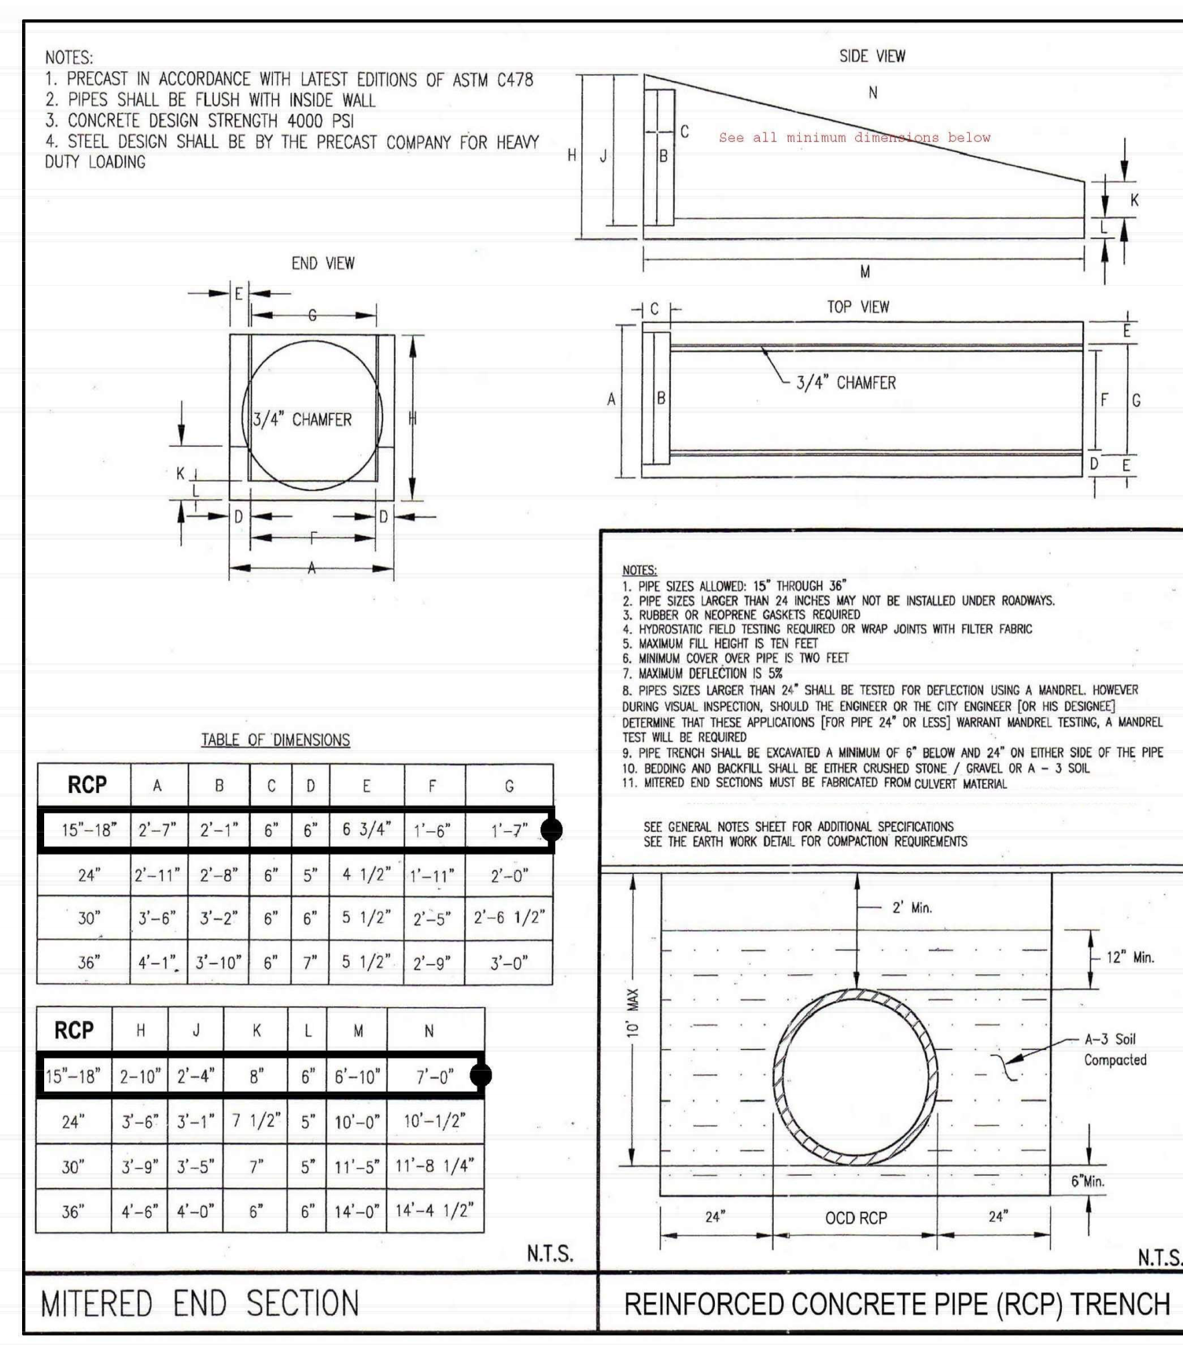

EXHIBIT “G”
JACKSONVILLE RANCH CLUB 1
APPROVED CONSTRUCTION SIGN
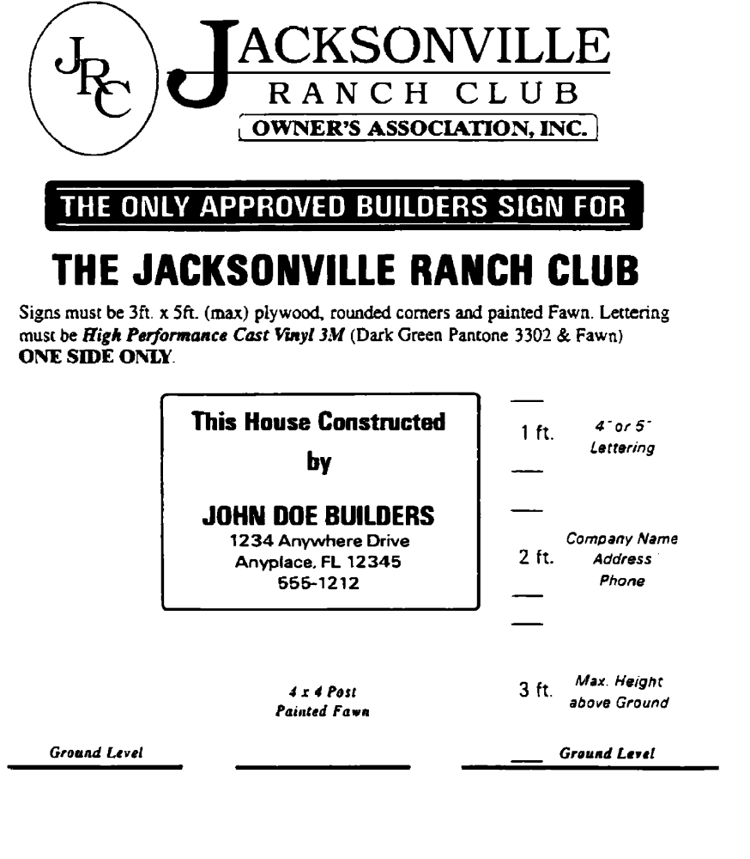

EXHIBIT “E”
JACKSONVILLE RANCH CLUB 1
RECOMMENDED PLANT MATERIAL AND TREE PALETT

ITEM # 7 (NCA)

Jacksonville Ranch Club - Standards and Criteria for New Construction

Items often missed on ARB plans for the Jacksonville Ranch Club

Site Plan
- Show Drive and approved material and show min. 5” Reinforced concrete from road to dwelling side of swale. Show the location of the culvert on the site plan.
- Show Concrete Culvert construction detail on plan and add size of RCP in Culvert, Concrete headwall and sidewall detail.
- Show location of well and how it shielded if not behind the dwelling.
- Show six each Minimum 4” caliper Non-Pine Variety Trees per lot on dwelling side of swale not in the swale (if any show existing trees other than pine 6” caliper or greater or any trees to remain).
- Show septic system and where drain field is located behind the dwelling.
- Show ac equipment and how it will be shielded if not behind the dwelling.
- Show water flow arrows on the lot.
- If Propane Gas is used show location where the propane tank will be buried.

Furnish Irrigation plan and sod area. Include the drive, material, and any item shielded from view of the street
along with the irrigation and landscape include the 4 min. Live Oak Trees with minimum 4” caliper.

Foundation Plan
Add note:
- (a)Minimum Finish Floor Elevations. Finished floor elevations shall be a
Minimum of 1.3 feet above the highest grade 10 feet away from the structure and .08
Feet above the highest grade immediately adjacent to the structure to ensure that the
Existing draining patterns are maintained and to ensure that the drainage is not adversely impacted blocking the immediate or adjacent property.

This note could be added on the typical foundation plan also

Elevation Plans
- Add note to paint all roof vents and Plumbing vents to match shingles.

Furnish colors
- Roof, Walls, Fascia, Front Door and Drive (if colored).

Garage
- Side load not facing street with the house address (if on corner).

Builders Insurance: Furnish a copy of the builders insurance for 1 million dollars showing Jacksonville Ranch
Club as ADDITIONAL INSURED

ITEM # 8 (NCA)
JACKSONVILLE RANCH CLUB 1 HOMEOWNERS ASSOCIATION
RULES AND REGULATIONS

